This project consists of two VI files (transmitter and receiver).

“Com port 1” and “Com port 2” of the same pc are connected by a male to male connector cable.

Transmitter VI writes data to port1, receiver receives it in port2.

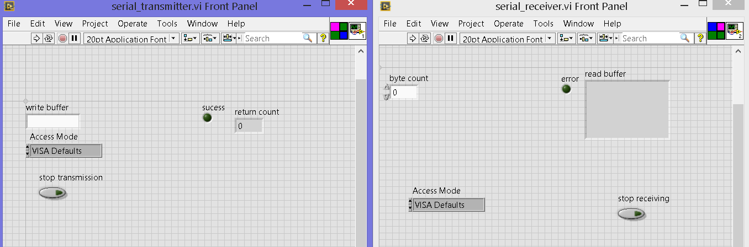

Com1 and com2 are virtually created by a third party software.

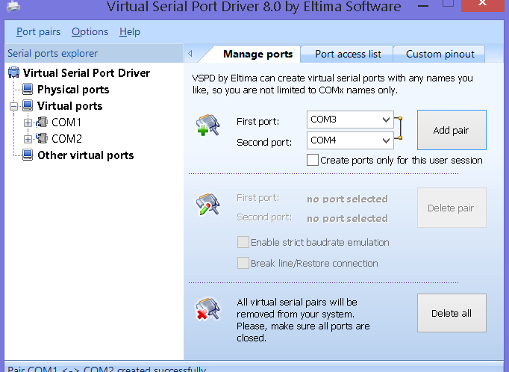

Transmitter starts to transmit India as its data.

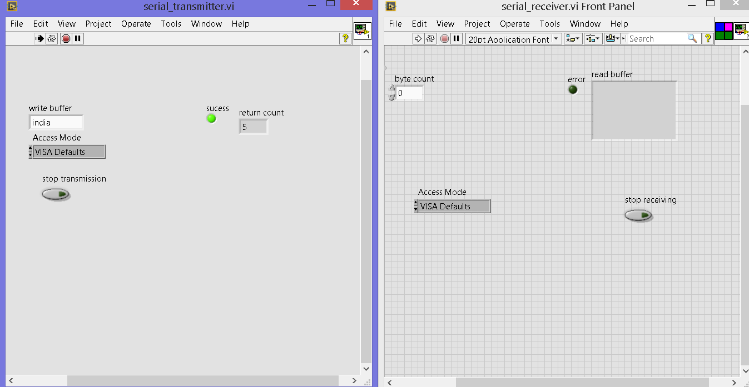

Transmitter opens a visa port and keep on writing data into it.

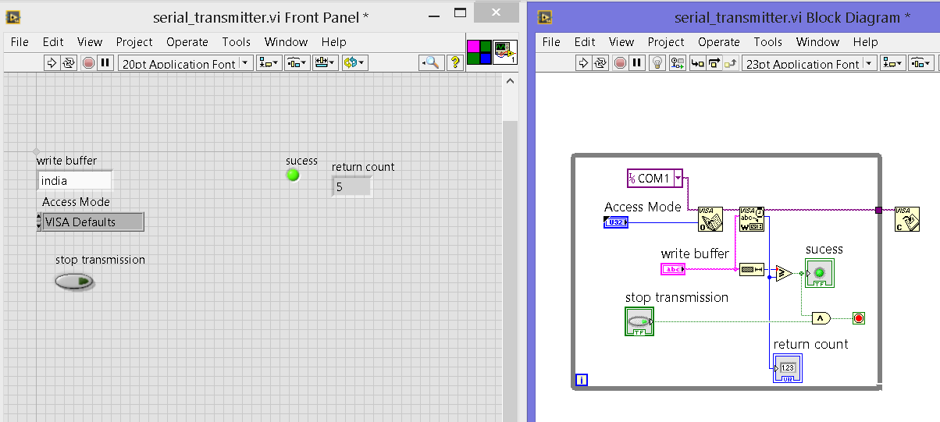

Then we need to set the byte count.

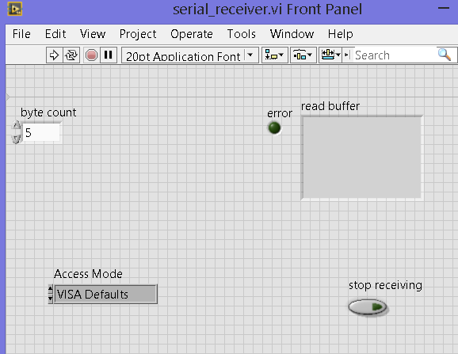

After setting byte count we start to run the program.

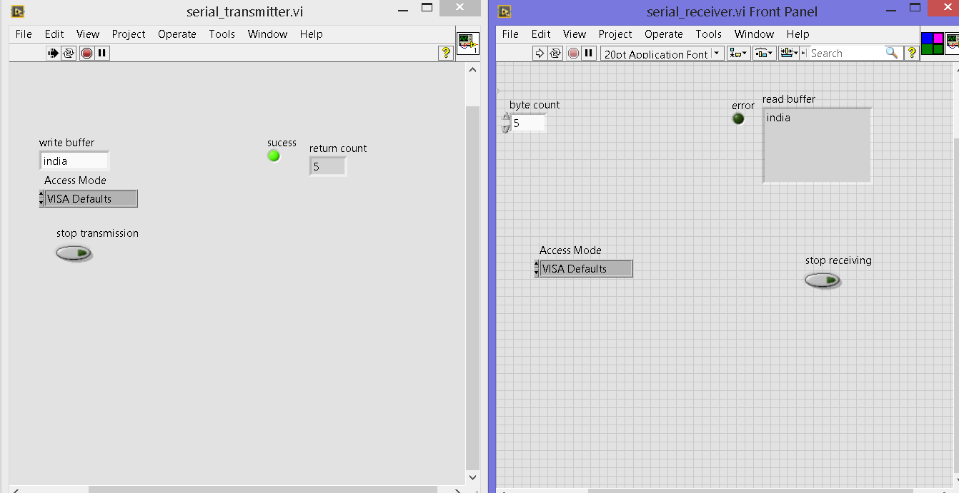

After receiving data from transmitter, receiver automatically stops its receiving process.